INSTALL ON DELPHI 7

These are the steps needed to install DsToolBar on Delphi 7:
- Open Delphi 7
- Select File|Open Project menu or press the key combination Ctrl+F11

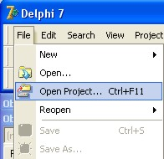

- In the Open Project dialog that appears, change the File of type field to Delphi Package (*.dpk, *.dpkw) like is shown in the screenshot below.

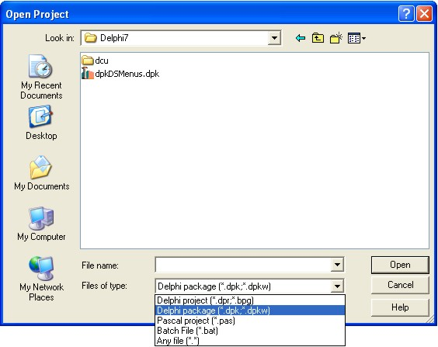

- In the Open Project dialog navigate to the folder where the DsToolBar files are placed and open the Delphi7 folder. The package file dpkDSMenus.dpk appears and a dcu folder like is shown on the screenshot above. Double-click with the mouse on the dpkDSMenus.dpk file or select it and then click the Open button.
- In the package editor that appears on the screen press the Compile button.

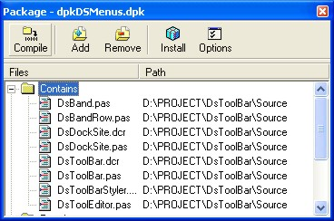

Wait to compile the project and than press Install button. Information window is shown with the newly installed components. Press OK button to close.

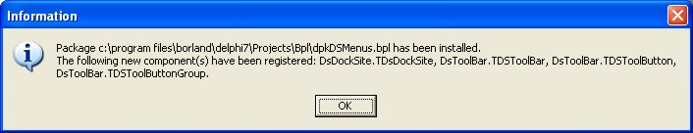

Save and close the package editor

- Open Tools|Environment Options… menu

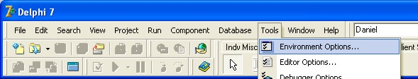

- Select the Library page in the Environment Options editor that appears.

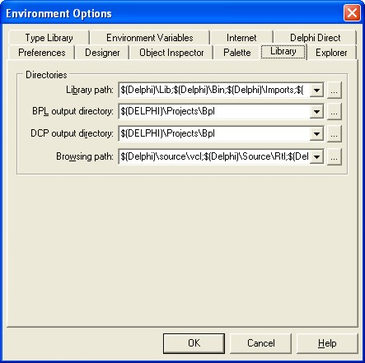

In the Library path field add the folder where the dcu files are placed. This folder is located at …\DsToolBar\Delphi7\dcu.
In the Browsing path field add the folder where the source files are located. This folder is …\DsToolBar\Source.

Installation is now completed.

The new components are placed in the Tool Palette in the Ds Menus page.

If arise problems with the installation of the components write to daniel@microdor.com

